13. Webhook Tutorial
To automatically trigger a Jenkins pipeline whenever code is pushed to a GitHub repository using a Webhook.

Step 1: Create a Pipeline Job
- Open Jenkins Dashboard.
- Click New Item.
- Enter the job name.
- Select Pipeline.
- Click OK.
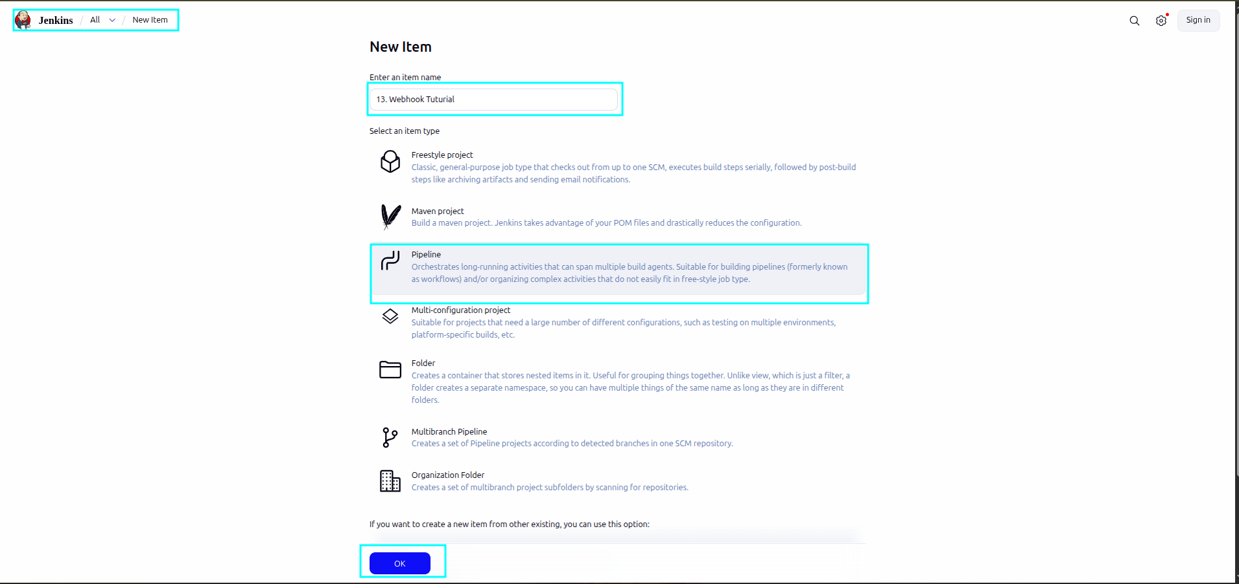

-------------------------------------------------------------------------------------------------------------------Step 2: Configure the GitHub Repository
- Scroll down to the Pipeline section.
- Select Pipeline script from SCM.
- Choose Git as the SCM.
- Enter your GitHub repository URL.
Example: https://github.com/username/repository-name.git
- Specify the branch: */main
- Set the Script Path: Jenkinsfile

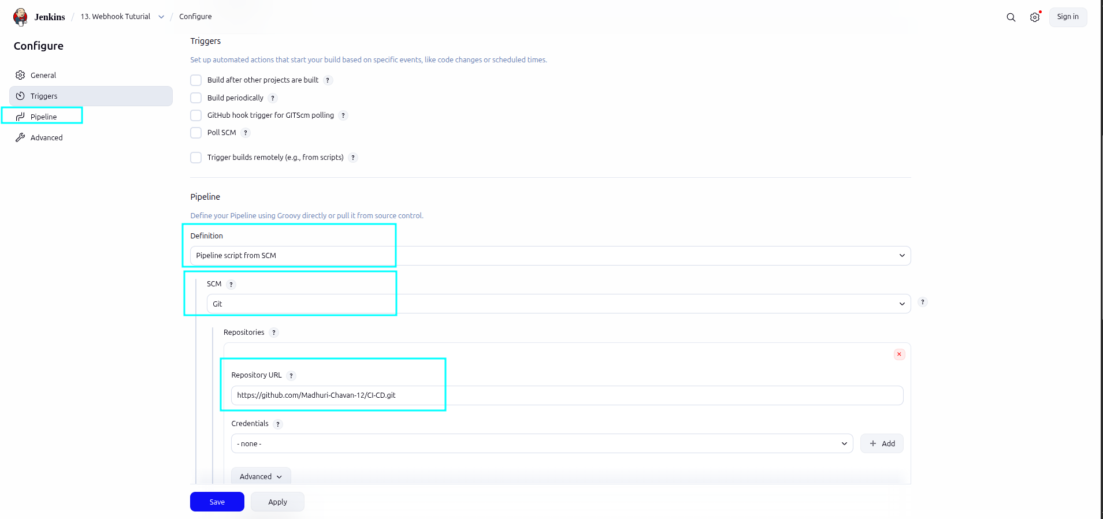
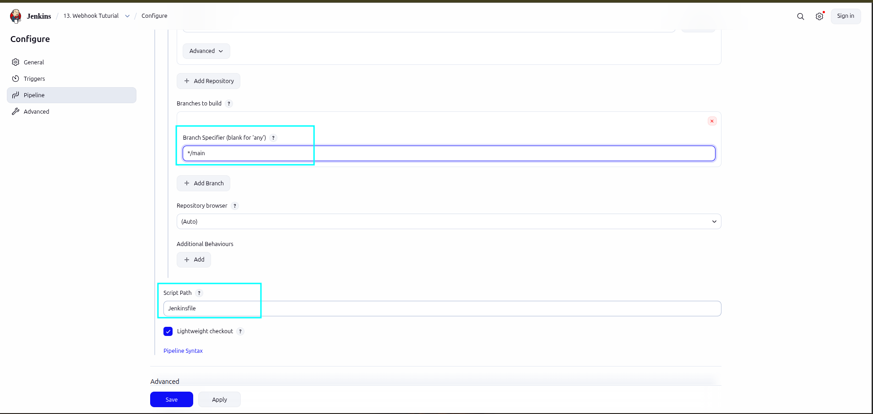

------------------------------------------------------------------------------------------------------------------------

Step 3: Enable GitHub Webhook Trigger
Open the Jenkins job configuration.
Under Build Triggers, enable: GitHub hook trigger for GITScm polling
Save the configuration.
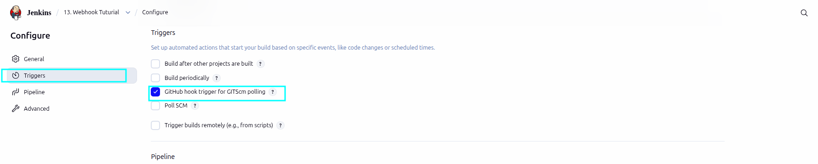------------------------------------------------------------------------------------------------------------------------

Step 4 : Create a Public Jenkins URL
If Jenkins is running on localhost, expose it using Ngrok.
Open a terminal and run: ngrok http 8080
Ngrok will generate a public URL, for example: https://flattered-never-stir.ngrok-free.dev/github-webhook/
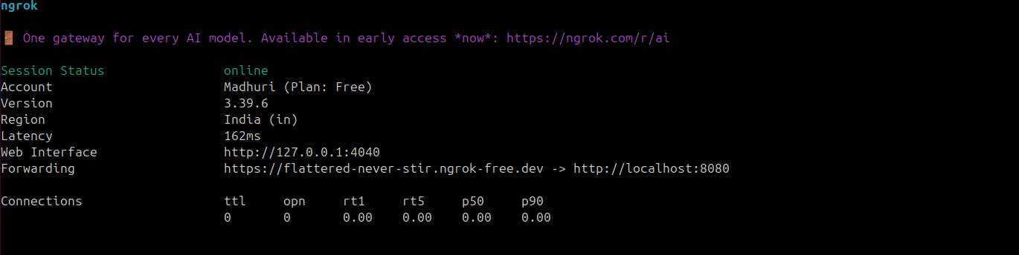------------------------------------------------------------------------------------------------------------------------Step 5: Configure GitHub Webhook
- Open your GitHub repository.
- Go to Settings → Webhooks.
- Click Add Webhook.
Fill in the following details:

Payload URL: https://flattered-never-stir.ngrok-free.dev/github-webhook/
Note: The URL must end with /github-webhook/.

Content Type: application/json

Which events would you like to trigger this webhook? : Just the push event
Leave the webhook as Active.
Click Add Webhook.
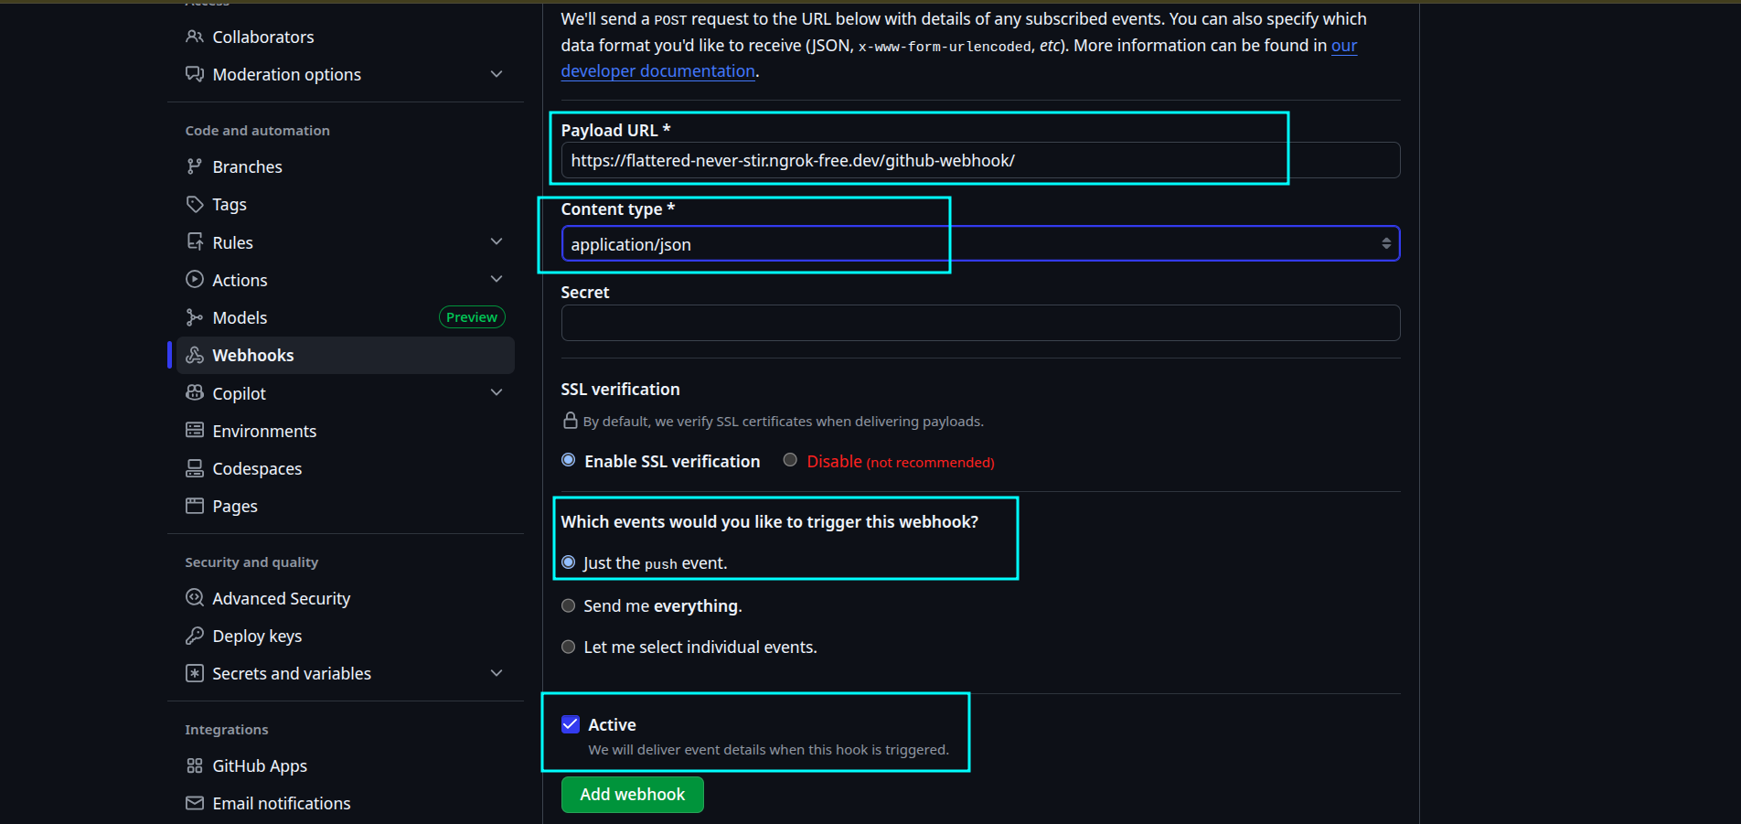------------------------------------------------------------------------------------------------------------------------

Step 7: Test the Webhook
Make a small change in your local repository and execute:
git add .
git commit -m "Webhook Test"
git push origin main
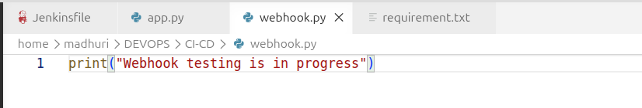
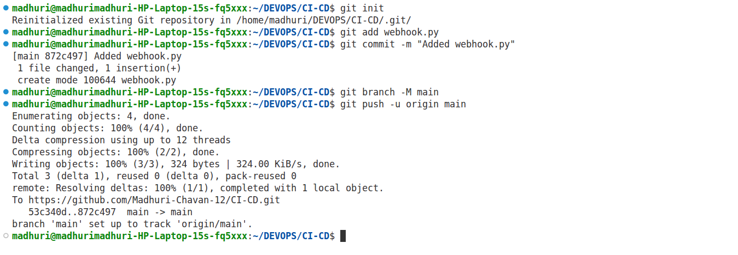

-----------------------------------------------------------------------------------------------------------------------

Step 8: Verify the Build
